Project charter
Define
Problem statement
Recently, there has been an increase in the number of employees in workplaces who go for long without food and drinks as accessibility to hotels is limited due to minimal time available. There has hence been an increasing need for a food truck business which will make it possible to offer employees with food and drinks to enhance performance of roles and responsibilities in the workplace. The use of the six sigma will indicate the improvement of results through increased performance and minimizing errors to enhance customer satisfaction overall.
Business case
The food truck business project is important due to the need to COVID 19 pandemic that has led to closure of hotel businesses in an aim to curb the spread. A food truck business will hence fill this gap leading to employees’ productivity.
The financial impact of the food truck business is an enhancement of continuation of everyday operations to enhance support to the economy at this time of the crisis.
The project impact on DPMO/ Sigma level is that it there will be provision of essential services as employees having been lacking food and drinks in the workplace.
The impact of the food truck business on customer service is satisfaction based on availability and affordability of the food and drinks a call away from their workplaces as it is mobile.

Goal Statement
The food truck business specific goal is to provide essential food in the workplace which is a necessity to productivity.
The food truck business measurable goal is to provide employees with food during the COVID-19 pandemic until the situation calms.
The food truck business achievable goal is to build a customer relationship showing continued support and care at this trying time.
The realistic goal is to provide food and drinks to employees in the workplace leading to productivity while at the same time accumulating minimal profit to enhance business continuity
The time bound goal is to satisfy customer needs during the COVID 19 pandemic period.

List of Improvement Goals  1.  2.  3.  4.  5. | Measure (units) | Baseline | Goal
List of Improvement Goals  1.  2.  3.  4.  5. | Numbers | 1 truck | Opening up more food trucks in different areas
List of Improvement Goals  1.  2.  3.  4.  5. | Efficiency | Work input | Making few mistakes
List of Improvement Goals  1.  2.  3.  4.  5. | Percentage | 100 customers | Increasing customer base line though low prices
List of Improvement Goals  1.  2.  3.  4.  5. | Numbers | 20 employees | Hiring more employees
List of Improvement Goals  1.  2.  3.  4.  5. | Percentage | $1000 | Revenue increasing

Process
It is in the employment sector where employees in organizations are lacking the possible means to food and drinks accessibility leading to lower productivity in the workplace. Hotels and food joints were closed with an aim to curb the COVID 19 pandemic spread but a number of employees in organizations are required to work from offices in shifts. Just like any other condition, one must be in a position to eat well for enhanced productivity in the workplace overall.
Project scope
The process entails on addressing the productivity of employees in organizations mainly enhanced through availability of food and drinks for enhanced productivity overall.
The boundaries within the food truck business are within the United Sates which has had increased number of COVID 19 cases. It is effective for the food truck business to operate within the affected areas to ensure operations are running effectively to ensure continuity.
The inside areas of focus in the food truck business are affordability, availability, satisfaction and preference.
 | Member Name
Project Sponsor | The US government.
Key Stakeholders | XYZ company, suppliers, customers, employees.
Team Lead | XYZ CEO
Team Members | XYZ company CEO, secretary, chairman and employees.
Process Owner | XYZ chairman
Other
Timeline by Project Stage | Milestone | Target Completion Date
Define | Project Charter and kickoff | 5th May 2020
Measure | Define and collect data | 7th May 2020
Analysis | Find causes | 9th May 2020
Improve | Fix causes | 11TH May 2020
Control | Standardize the fix | 16th May 2020

Team Charter

Project Title | Food Truck Business
Expectation | Example | Team Rule
Attendance | Attendance is required at all team meetings. Changes in meeting times must be made at least 24 hours ahead of time. | Everyone must be available at the right time without failure to avoid complications and misunderstandings | ****+ //
` | Team members may not be substituted unless approved by team leader. | Teamwork and total commitment for attainment of the best results.
Focus | We will stay on task and on topic, using the Project Charter as our guide. A meeting agenda will be published at least one day in advance. | Mistakes should be avoided in the best way possible through adhering to rules and regulations.
Interruptions | Interruptions for emergencies only. Phones turned to silent. | Silence in the workplace is a virtue that is highly appreciated.
Preparation | All deliverables are expected to be completed in a timely manner. Each meeting will have a published agenda. | Employees are expected to conduct themselves by adhering to time for the respect to positions in the workplace
Timeliness | Meetings will begin promptly as scheduled. | Lateness is taken as disrespect to one’s position in the workplace.
Decisions | We will choose the best decision-making method for each situation. We will support decisions made by the team. | Critical thinking before making decisions is expected for a successful organization.
Data | We will rely on data to make decisions. | Planning is based on data forecasting and analysis to coin the best ideas.
Conflict | We welcome honest disagreements, as long as everyone is treated with respect. A facilitator will be used if conflict cannot be resolved. | Learning from failures to make the best decisions in future and avoid similar mistakes form occurring time to time.
Other
Team Member | Role | Signature
CEO | Overlook the operations at the company
Employees | Enhance customers’ needs are met without failure
Chairman | Consultations
Treasurer | Overlook finances
Decision making | Collaboration in meeting customers’ needs | Teamwork
Safe working conditions | Raising concerns in case of misunderstandings | Adherence to rules and organizations

Measure
The need for a Food truck business requires the collection of data to have a determination on whether it will be successful or not. The main data collection methods to use are questionnaires and interviews aimed at attaining first-hand information regarding the success of a food truck business when COVID 19 pandemic has claimed many lives in the United States. These two data collection techniques are aimed at measuring the effectiveness and suitability of establishing the food truck business which will be effective in priding employees in organizations with food and drinks to enhance more productivity and continuation of economic support at these hard times. The data type concerning this scenario is qualitative specifically binary data as questions will be based on the people answers whether right or wrong. Based on this, there will be an execution of a strategy which will be effective in helping to discover what potential customers think on establishing a food truck business available at the comfort of their working environments. The data collection plan for the successful attainment of results is one on one questions answering and even phone calls questionnaires and interviews as data collected in this way will be first hand.
Initially, it was determined that customer satisfaction would be low due to lack of awareness and lack of an understanding of the food truck business adherence to hygiene.
The statistical table below indicates the initial reaction to potential customers on establishing a food truck business.
Area of specification | Score in percentage according to customers | Expected score in the food truck business
Hygiene | 40% | 97%
Adherence to rules and regulations | 50% | 95%
Prices | 60% | 97%
Overall satisfaction | 67% | 98%

The food truck business aims at increasing the scores in percentage through improving the 4 specific areas leading to improvements and hence an effective running of the operations overall leading to success. Using calculations, the initial overall score of the food truck business in regard to success can be calculated:
40+50+60+67=217
217/4=54.25%
It is clear that the possibility of the success of the business is not guaranteed as the score can be termed as average. Measures hence need to be taken to increase trust and enhance more influx of potential customers in organizations around the US.
Analyse
Process map
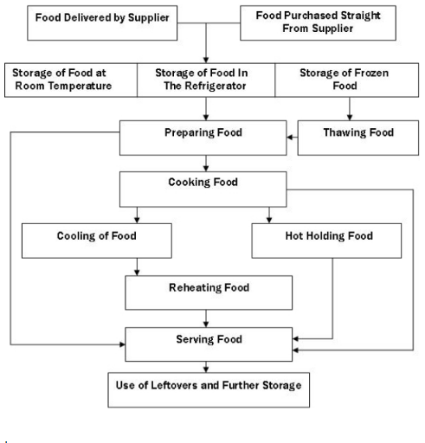

The implementation of a process map in the food truck business ensure all safety measures are taken into consideration enabling minimization of errors that might occur and adherence to guidelines on health enhancement. This will lead to increased productivity hence an overall running of the business meeting the areas of specification

Null and alternative hypothesis
There is the need to have a speculation about the problem in question which is whether establishing a food truck business will be successful to enhance employees’ productivity when the world is in a health crisis. The null hypothesis in the problem statement is that there will be an increase in production in organizations through offering low costly food in food trucks at the comfort of employees in the workplace. The alternative hypothesis, on the other hand, is that a food truck business will lead to acceptability or rejection based on the approach and hygiene to the provision of food in the United States. These two hypotheses are effective at XYZ as a food truck business which is effective for the overall economic assistance in the United States.
Improve
There are several improvements in establishing a food truck business in the United States which will be effective in making sure the overall success is effective. The situation that COVID 19 has put hotels operations is not effective as social distancing is not possible to be maintained. When it comes to a food truck business, the idea of providing take away food is effective as it will enhance social distancing overall hence effective health improvement. One of the improvements is to provide healthy food free from consumption making it possible to curb the COVID 19 spread. The other area of improvement is prices lowering due to an understanding of the crisis in the economy and the need to provide affordable food and drinks to potential customers who are risking their health for the economy to run. The other areas of improvement are customer relationship building and satisfaction. The one area selected for improvement is providing the provision of healthy food and drinks overall. The process of selecting the improvement is based on overall health since failure might lead to more health complications leading to more spread of the coronavirus.
In an attempt to determine the factors affecting the need for improvement of the Sigma level in the food truck business, FMEA was carried out and a determination of the relevant course of actin which will lead to the success and preference of the food truck business.

Cause | Effect | Action to take
Inadequate skills | Low quality output | Training
Low number of employees | Inadequate work done | Hiring more employees
Lack of teamwork | Taking long to solve issues at hand | Employees collaboration

Control
Health is one of the concerns since providing food and drinks using a food truck to employees in organizations can be one of the ways through which coronavirus can spread. XYZ Food Truck Business aims at creating awareness on the need to maintain social distance and promoting sanitization for overall improvement. With this in mind, the Food Truck business will provide customers with high-quality products suitable to improve the overall health for employees leading to productivity. The food truck business also aims at providing high-quality food and drinks at affordable prices necessary for improved employees’ performance overall.
When all the areas of that needed improvement were determined and the relevant course of actions taken, ABC food truck business. The results of the food truck business after all the improvements were taken into consideration and relevant action taken, there was an increase which led to a determination of success in the business engagement serving customers’ needs during COVID 19 pandemic.
Below is a table of the results after implementing the right measures at ABC food truck business which led to increased customer satisfaction and success overall.
Improved areas | Percentage scores
Hygiene | 99%
Rules and regulations adherence | 97%
Prices | 94%
Overall satisfaction | 98%

The implementations of the suggestions were a true revelation of the continued enhancement to reach the overall success of the food truck business.
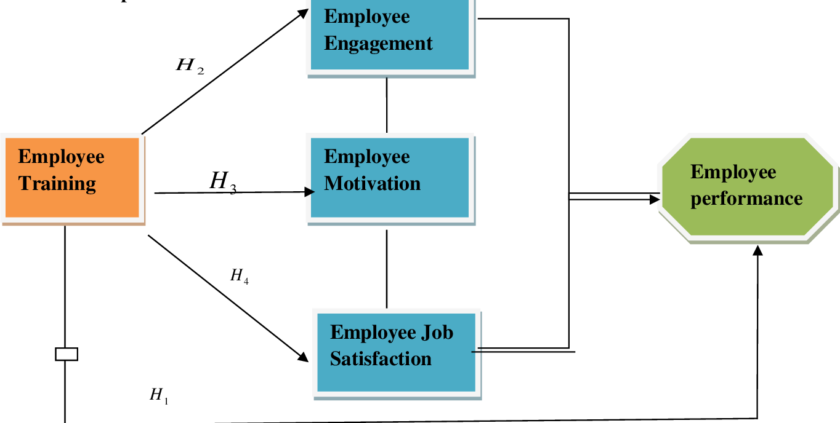
The diagram above is an illustration of one of the areas of consideration that will lead to increased employee performance leading to successful running of the food truck business.

Short Reflection
The success of a business is highly determined by the strategies put in place making it possible to overcome the situations hence an attainment of success. With this in mind, a business puts the best implementations in place hence the ability to overcome situations at hand in a time when the global economy is facing a pandemic.

